Gene-Sys Screenshots (Core Production Screens)

Cascading Selection Sets
The “Exclusions” tab is used to define what records are to be excluded from this Order (they can be Previous Orders, Suppression File Uploads from the Client which can also be cross Client – should we EVER need to). Suppression Uploads can be done via telephone number, postcode, region or prefix and email address.
Sets can be dragged above and/or below so as to re-order easily – good for cascading selections / prioritising which Set to include 1^{st,}, next, last).
Any Set can be saved as a “Template” so as to be re-useable – these can then be inserted into any Order by clicking the “Templates” button.
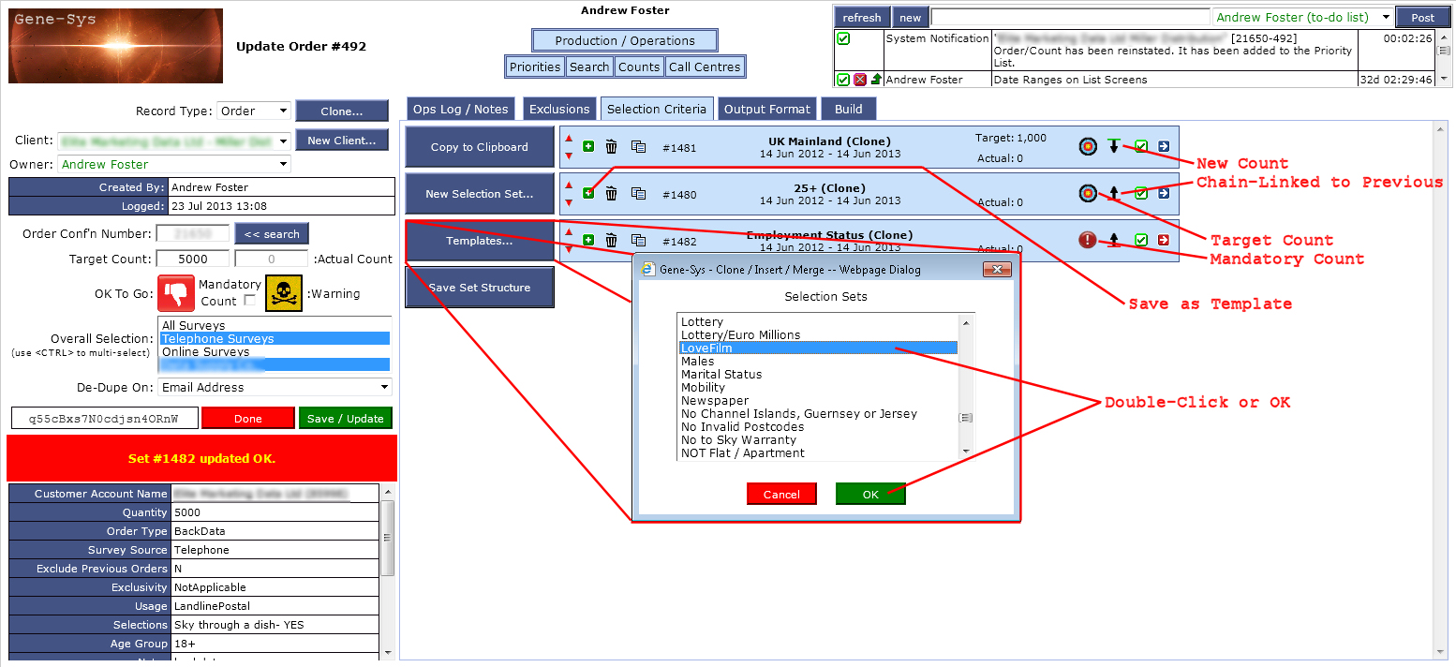

Edit a Selection Set
By dragging each Criteria row either by its “body” or it’s “tail”, they can be nested up to 20 levels deep (like that will ever need to happen!)
Perfect for (((A and B) or (C and D)) and (E or F)) BODMAS type logic.
ALL form buttons flash yellow when data has changed to warn the user to save the current setup.
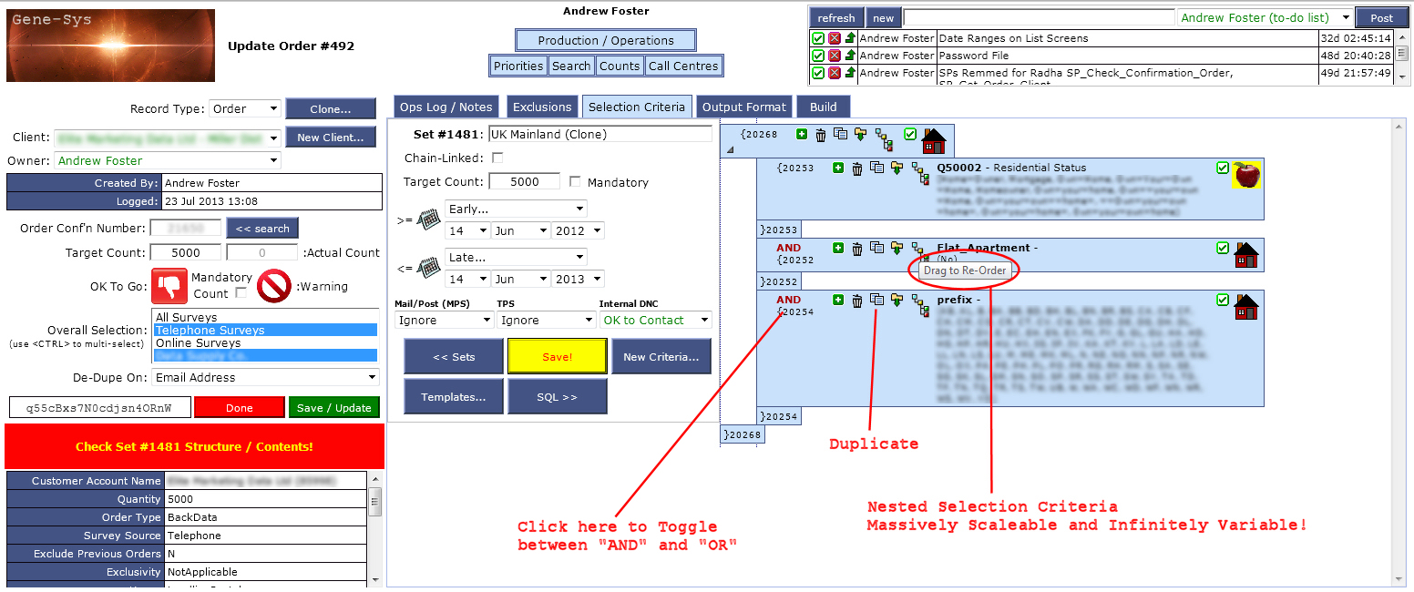

Edit Criteria
Individual Criteria can be selected from Demographic Info or specific Survey Questions’ data.
The ability to sell First Usage, Second Usage and historic List Data is possible at relatively priced values.
The ability to select specific values or just whether the field is populated (or not) is available (see “Survey Data” in screenshot).
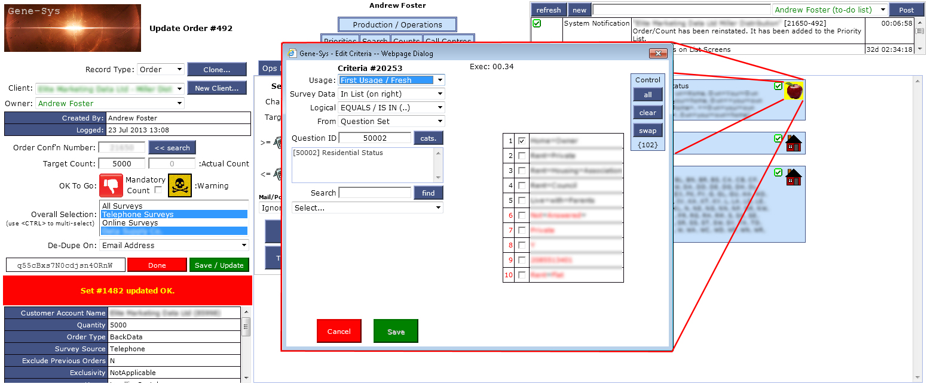

Build / Count
This is used to do a quick check on whether the Selection Sets’ Criteria can actually be fulfilled – without going to the effort of actually producing possibly huge data lists and it then fail due to lack of records.
As can be seen, set 3 yields 0 records, but Set 1 can fulfil the Order anyway, so we can continue with the Order as is.
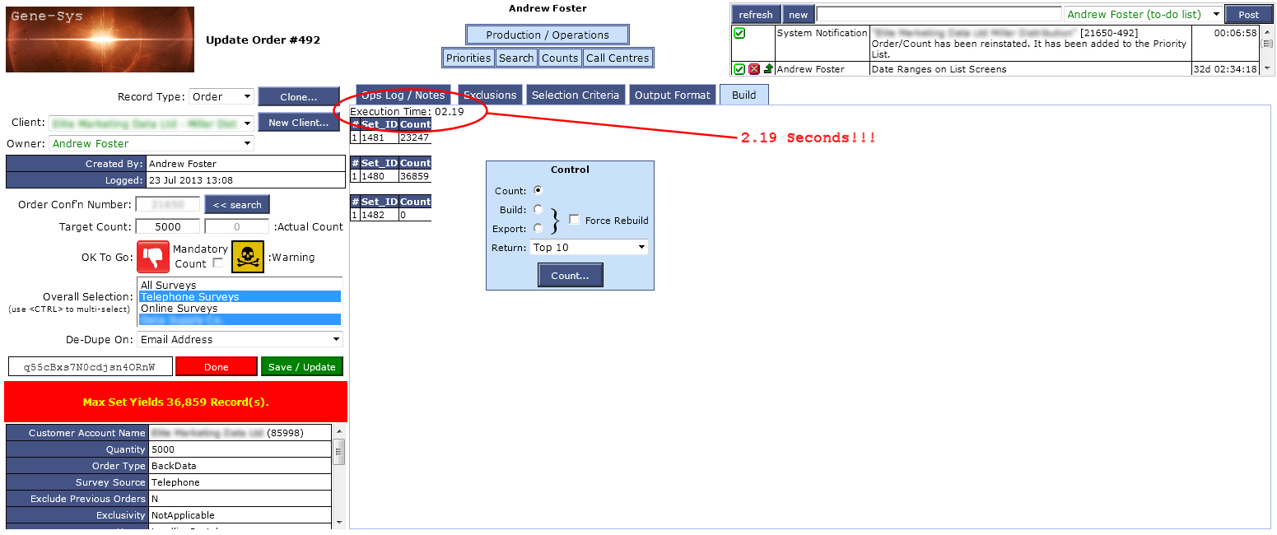

Build Order / Sense Check the “Output Format”
The “Output Format” tab is a very basic selection mechanism and not important here. We generally use the same layout which is Templated anyway and so rarely needs re-ordering or amending.
All the tabs are loaded into their own areas (and only when needed), so navigating between each tab takes no additional effort from the server or browser – keeping production times as low as possible.

